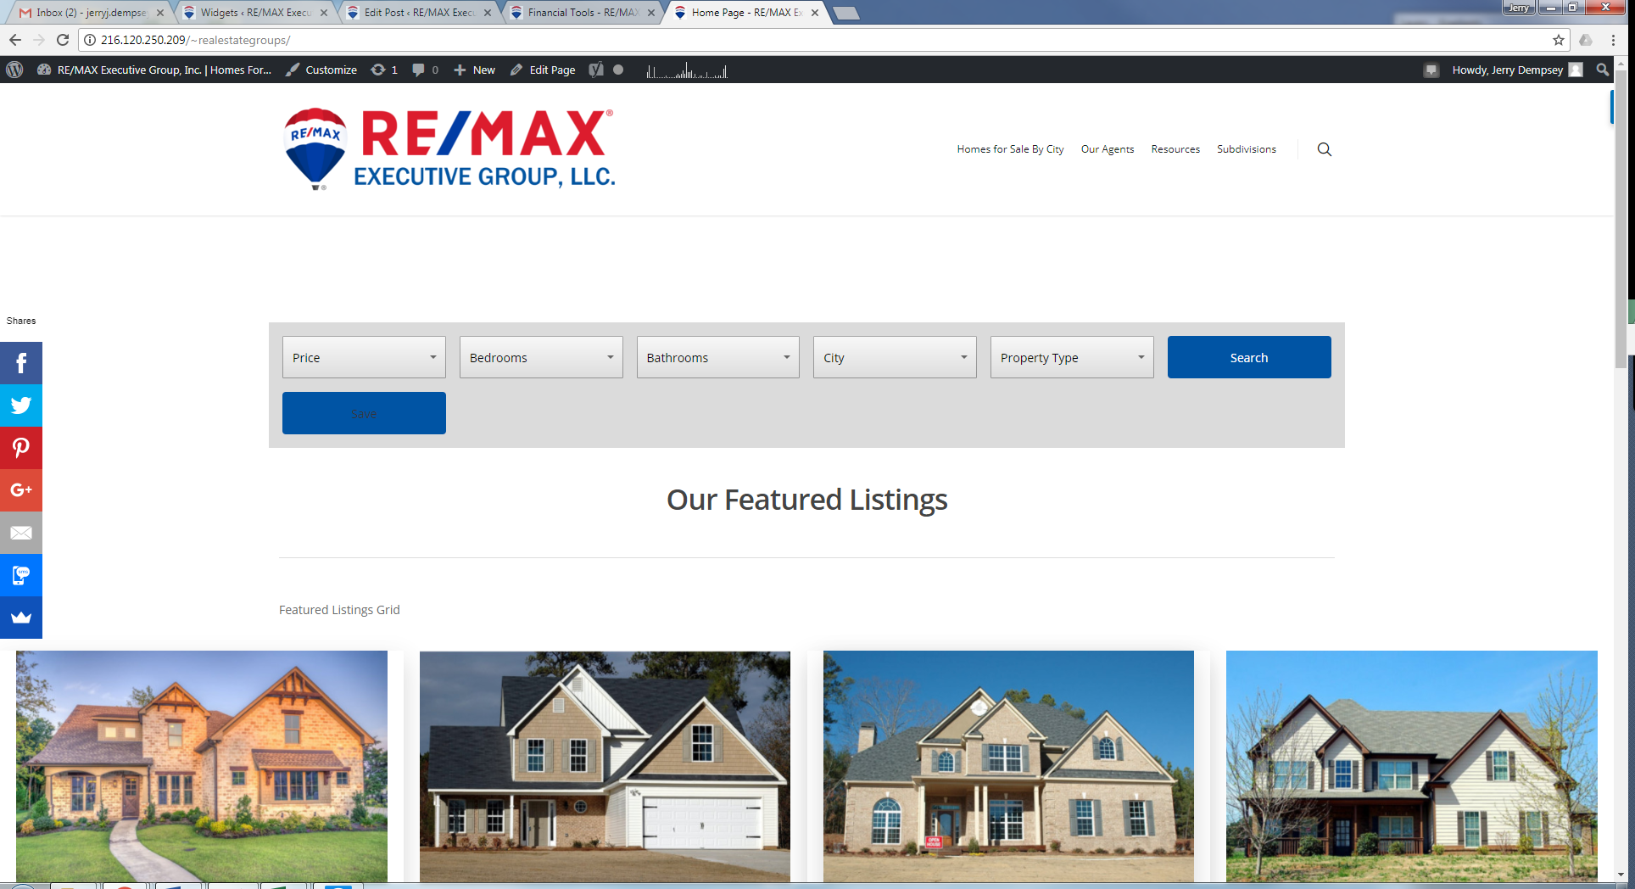

There is a gradient to the buttons in the bar above that is not on the sidebar. I would like the sidebar to also have this gradient effect.

The border around the menus on the top bar makes them appear raised. The sidebar field borders appear lighter.

The font does not pop as much on the sidebar. I am not sure if it is just a little darker on the top bar.

